Script-Controlled ACL – Restrict Record Access Based on Field Value

Project Overview:

Description :
This lab demonstrates how to implement a script-controlled Access Control List (ACL) to restrict users from viewing records unless they meet specific conditions. In this scenario, only users belonging to the EEE branch are allowed to view records where the Branch field is set to EEE, while administrators retain full access.

Milestone-1 Creation of Users and Roles

User Creation:
- Log in to the ServiceNow instance with admin access.

Create a test user:
  - Navigate to User Administration → Users
  - Click New
  - User ID: EEE User
  - First name: EEE
  - Last name: User
  - Email: eeeuser@gmail.com
  - Save the record
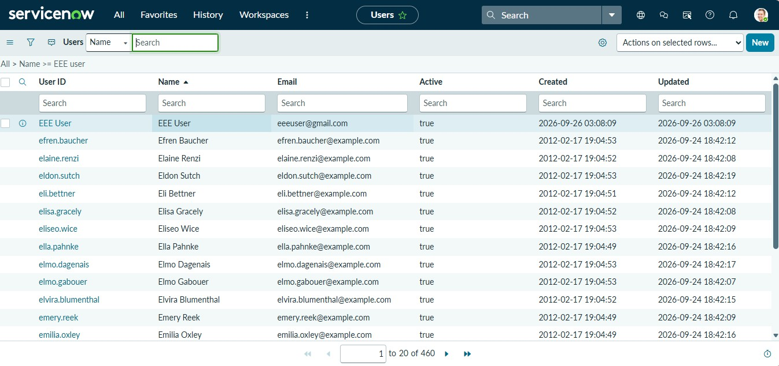

Role Creation

- Navigate to User Administration → Roles
- Click New
- Name: Enter role name as bb1
- Description: Brief role purpose
- Click Submit
- Create other roles also like bb2,bb3,bb4.(follow the same procedure)
- Assign all the roles to the EEE User

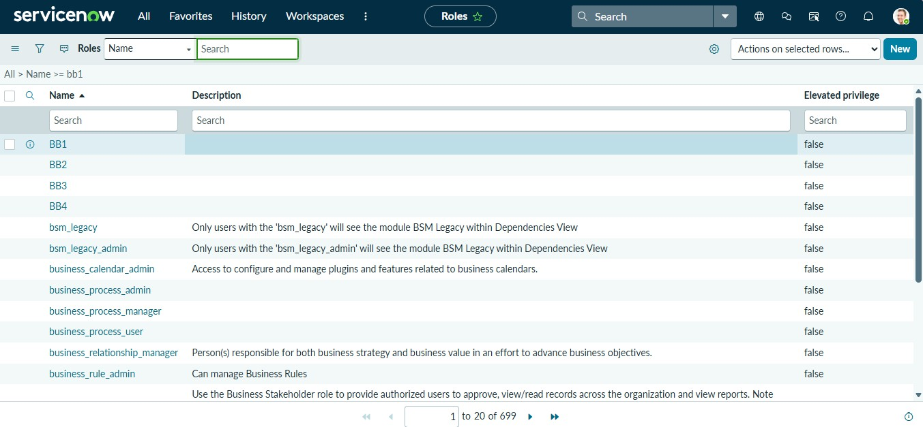

Milestone-2 Tables Creation
- In the Application Navigator, search for System Definition → Tables.
- Click New and create a custom table with the following details:
  - Label: Institution Details
  - Name: u_institution_details
  - Extends for : false
- Click Submit.
- Add the following fields to the u_institution_details table:
  - Student Roll Number– Auto Number
  - Student Name – Reference- User
  - Faculty Name – Reference- User
  - Branch – Choice (ECE, EEE, CSE)
  - Email– String
  - Phone Number– String

  - Description– Multi String
- Save the Table

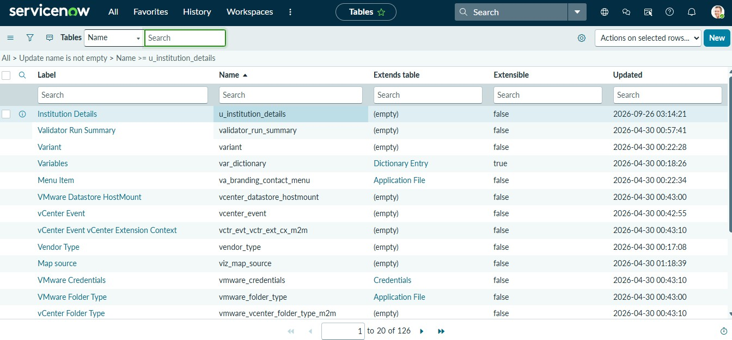

Milestone-3 Creation of Access Control Lists (Read ACL)
- In the Application Navigator, search for System Security → Access Control (ACL).
- Elevate “Security_admin” role
- Click New to create a new ACL.
- Enter the following details:
  - Type: record
  - Operation: read
  - Name: u_institution_details
  - Active: true
  - Advanced: true
- In the Requires role related list, add:
  - bb1 (custom role)
- Add Data condition as Branch is EEE
- In the Script field, add the following script: (function () {
// Allow admin users full access if (gs.hasRole('admin')) {
return true;
}

// Allow only EEE branch users to see EEE records if (gs.hasRole('bb1')){
return true;
}
// Deny access for all others return false;
})();

- Click Submit to save the ACL.
- Impersonate EEE users and open the Student Records list.
- Copy the table name u_institution_details.list/LIST and paste in the All menu.
- Impersonate Admin and open the Student Records list.

User with bb1 role can view only EEE branch records
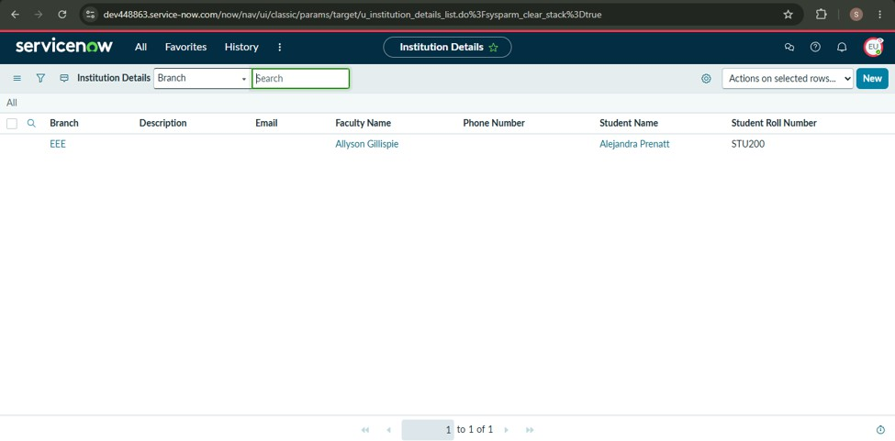

User without the role cannot view any records

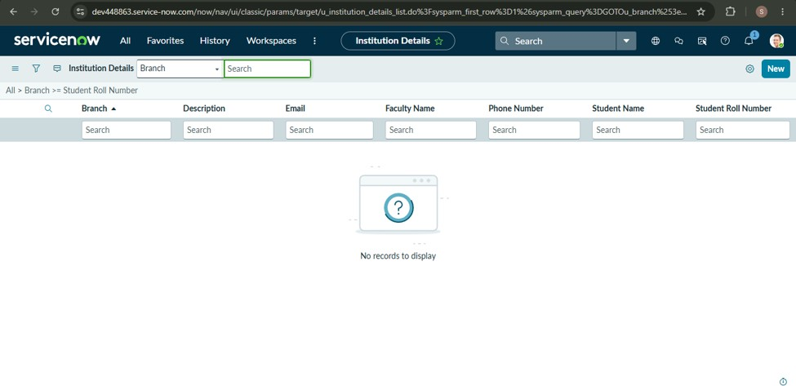

Admin user can view all records regardless of branch
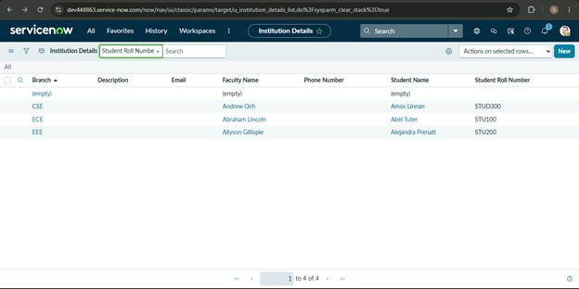

Milestone-4 Creation of Access Control Lists(Create ACL)

- Click New to create a new ACL(Create)
- Enter the following details:
  - Type: record
  - Operation: create
  - Name: u_institution_details

  - Active: true
- In the Requires role related list, add:
  - bb2 (custom role)
- No need to add any Data condition
- Save the ACL Record
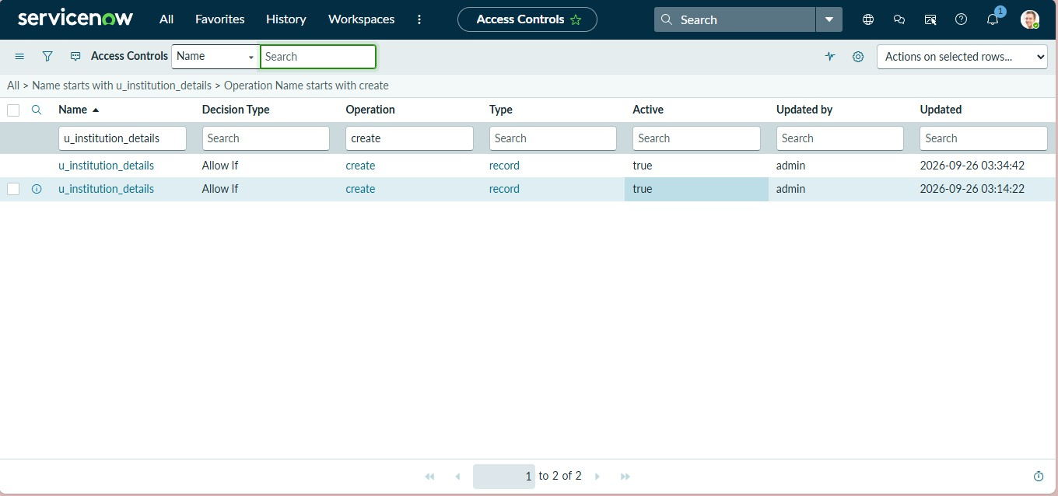

Milestone-5 Creation of Access Control Lists(Write ACL)

- Click New to create a new ACL(Write)
- Enter the following details:
  - Type: record
  - Operation: Write
  - Name: u_institution_details
  - Active: true
- In the Requires role related list, add:
  - bb3 (custom role)
- No need to add any Data condition
- Save the ACL Record

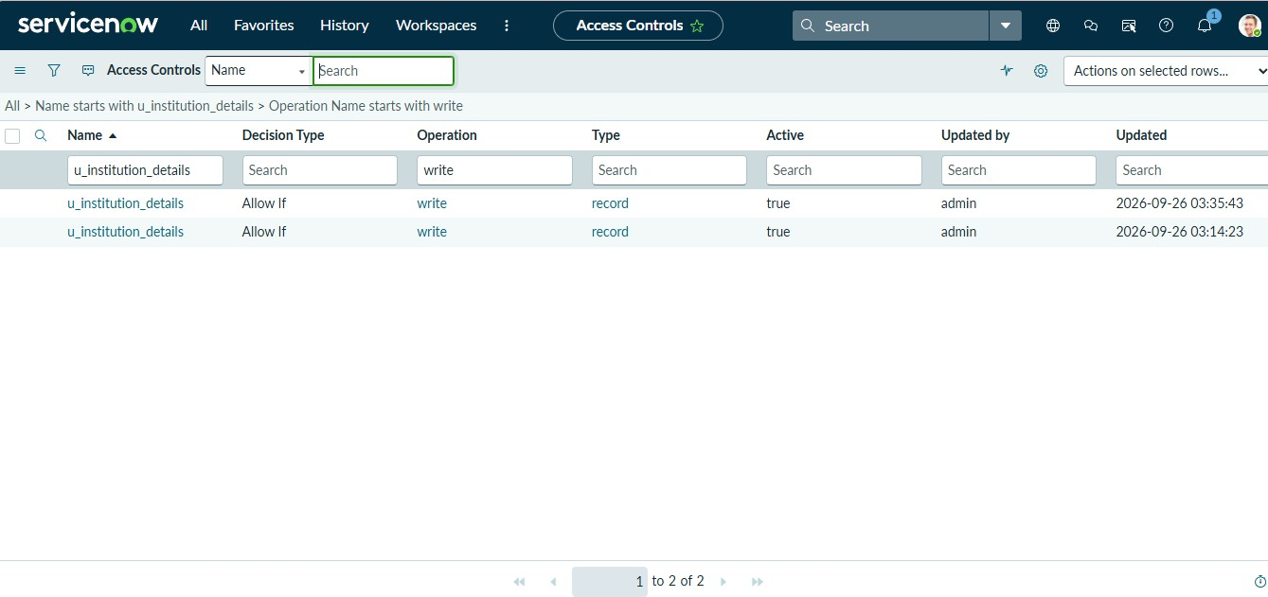

Milestone-6 Creation of Access Control Lists(Delete ACL)

- Click New to create a new ACL(Delete)
- Enter the following details:
  - Type: record
  - Operation: Delete
  - Name: u_institution_details
  - Active: true
- In the Requires role related list, add:
  - bb4 (custom role)
- No need to add any Data condition
- Save the ACL Record

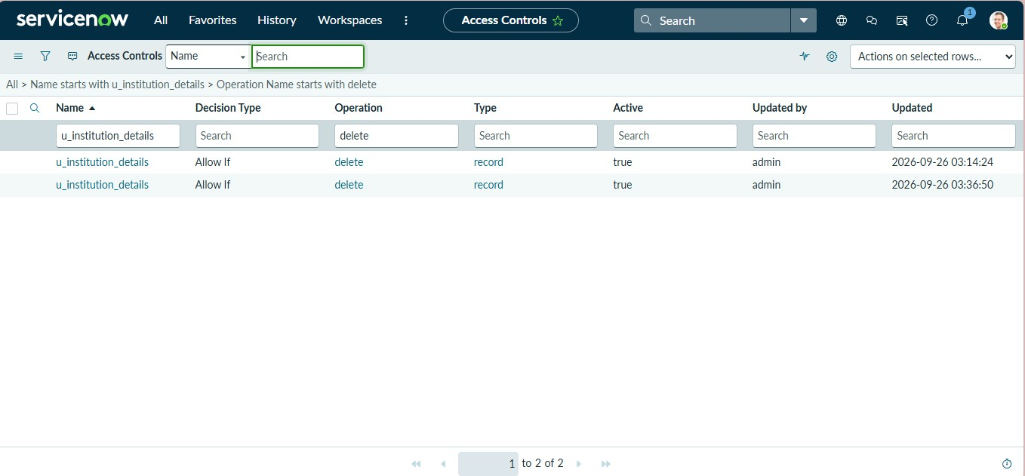

Outcome :
By completing this lab, learners gain a comprehensive understanding of how script-controlled READ, WRITE, CREATE, and DELETE ACLs enforce record-level security, how user roles and record field values are evaluated together to make access decisions, and how ACLs protect sensitive data from unauthorized viewing, modification, creation, and deletion across forms, lists, and Service Portal interfaces.

